Customer Analytics MARK 5001
Group Members
Krisha Shah | a1984222
Yana Nawargaonkar | a1953920
Prasad Yewle | a1977084
Pratyush Jayant Waghe | a1975270
Submission By 18th May 2026

Executive Summary
This report represents a comprehensive analysis of an e-commerce retailer’s channel and campaign performance data for 2023. The analysis was conducted using Google Looker Studio as the primary visualization tool, with data sourced from the assignment instruction, comprising of daily campaign records and monthly channel performance metrics across various channels and advertising campaigns.
The findings reveal that Paid search delivers the highest AOV at $112.84, making it the most valuable channel by customer spend per transaction while Organic search and Digital remain significantly underexplored relative to their growth potential. Monthly analysis confirms that May ($369,553) and April ($316,048) are the strongest months, whereas February represents a critical month with only 177 transactions complemented by lowest AOV and revenue despite 52,213 users. At campaign level, Ongoing specials is the best-performing campaign by order volume and revenue ($29,131.07); it also maintained CPO well below the target. On the other hand, Seasonal savings performed the weakest in CPO and exceeded the target threshold and also had the lowest AOV among rest of the campaigns. Annual Value Offers delivered the highest AOV ($101.86), representing a premium customer segment.
Topline recommendations include investigating the February sales anomaly and conducting root cause analysis to verify whether it was seasonal, or some other factors resulting in such low AOV to avoid it in future. Additionally, Paid Search channel delivering the highest AOV ($112.84) should receive increased budget allocation particularly during peak months of April & May to potentially attract high value customers. According to campaign analysis, focus should be on directing more budget allocation towards Ongoing Specials, which has strong revenue potential with lower costs per order.
Chapter  No. | Table of Contents | Page No.
1. | Title | i
2. | Executive Summary | ii
3. | Introduction | 1
4. | Literature Review | 2
5. | Methods | 4
6. | Analysis & Findings | 5
7. | Discussions Limitations & Recommendations | 9
9. | References | 10
10. | Appendices | 11

3. Introduction
Digital commerce has reshaped the way retailers find new customers and keep existing ones, with global e-commerce sales expected to pass US$8 trillion by 2027 (Chaffey & Ellis-Chadwick, 2022). In such a cluttered market, turning complex data into something actionable insight for business can become a real competitive advantage. The problem is that having data and using it well are two different things. Tools like Google Analytics and Looker Studio contains huge amount of data in real time, but many organizations still find it hard to turn those numbers into a clear story about which channels deserve more spend or which campaigns are worth running (Järvinen & Karjaluoto, 2015).
This report looks at 2023 performance data for an e-commerce retailer and tries to evaluate its customer-centric campaigns and digital channels. The analysis draws on two datasets: daily campaign data covering Annual Value Offers, Seasonal Savings, Ongoing Specials and Everyday Bargains, alongside monthly channel data covering Direct, Paid Search, Affiliates, Display, and other acquisition sources. The data sits in Google Sheets as a cloud-based warehouse and is analyzed in Google Looker Studio.
There are three things we are expected to do in this project. The first is to see which channels generate the highest Average Order Value and which are not being used to their full potential. The second is to compare the four campaigns against a $37 Cost-Per-Order target and check whether efficiency is improving between October and December 2023. The third is to turn our findings into practical recommendations and flag the limitations. A literature review, methods, analysis, discussion, and recommendations are below.
4. Literature Review
This review covers two areas that sit at the heart of the analysis: customer-centric campaign performance and channel performance. They share a common problem. Both rely on metrics that are easy to record but harder to interpret, and there is still genuine disagreement in the field about whether the standard digital indicators really capture customer value or simply move in the same direction.

4.1 Customer - Centric Campaign Performance
Digital marketing has moved away from broadcasting product messages and towards customer-centric engagement, where campaigns are built tailored to individual consumers want, prefer, and are worth over time (Kumar & Reinartz, 2018). Customer centricity should be a fundamental thing for good marketing practices, keeping in mind customer relations to be long term game than one off instance till the transaction is completed, this is what keeps a business profitable in the long run. In practice, this is tracked through a familiar set of campaign metrics: impressions, clicks, orders, revenue, and cost, along with derived ratios like click-through rate, conversion rate, and Cost-Per-Order (CPO) (Chaffey & Ellis-Chadwick, 2022).
Researchers do not agree on whether these numbers really tell us much about customer value. Pauwels & van Ewijk (2020) hints that engagement signals, repeat visits, and social interaction results in long-term revenue better than click-through rate, and that dashboards should focus on depth rather than reach. The retailers should be putting more into engagement, and if the sceptics are right, dashboards may be giving marketing too much credit. The practical middle ground (Kumar & Reinartz, 2018) is that engagement is necessary but not enough on its own and should be checked against relational measures like Customer Lifetime Value (CLV) and Net Promoter Score (NPS) before drawing causal conclusions.
This exposes a genuine problem in how most teams work day-to-day. Standard dashboards, including Looker Studio does a decent job tracking transactional data but rarely integrate relational indicators (CLV, NPS, sentiment, retention cohorts) needed to judge whether a campaign truly built lasting customer equity. A properly customer-centric setup would bring both the transactional and relational sides together.
4.2 Channel Performance
The same issue shows up, at the channel level. E-commerce retailers work across a mixed set of channels: organic search, paid search, direct, social, affiliates, and display, and each one comes with its own costs and conversion patterns. Looker Studio covers the usual channel metrics, including users, sessions, bounce rate, pages per session, conversion rate, transactions, and revenue (Chaffey & Ellis-Chadwick, 2022). These help separate channels that bring in scale from those that bring in depth or genuine value. Bleier et al. (2019) show that direct traffic generally converts better because those users already know the brand, while paid acquisition tends to bring in volume without the same engagement, progressively.
Two things make this harder than it looks. First, channel benchmarks do not translate cleanly across each other. A 70 percent bounce rate might be fine for a paid search landing page but worrying for an email campaign (Kannan & Li, 2017), which means comparing channels side by side without context could be misleading. Secondly, last-click attribution, which is still the default in most analytics tools, gives all the credit to the last channel a customer touched and ignores everything that happened earlier in the funnel (de Haan, Wiesel, & Pauwels, 2016). That works against awareness channels like display and social and makes direct and branded paid search look better than they really are.
Channel KPIs are routinely treated as directly comparable and usually clear, when they need channel-specific benchmarks, multi-touch attribution, and qualitative input to support good decisions. The present analysis sticks with the conventional indicators in the dataset to stay comparable with industry practice but keeps in mind its limitation, channel-specific norms, and the missing relational metrics that a fully customer-centric view would ideally include.
5. Methods
The data source for this analysis is the E-commerce Customer, Channel, and Campaign Performance dataset for 2023, provided in the assignment instruction in MS Excel format. The contains two sheets: first, Daily Campaign Performance Data and second, Monthly Channel Performance Data. The dataset was imported into Google Sheets as a data warehouse and connected to Google Looker Studio which was used as a primary tool for ETL, visualization, and analysis.
Derived metrics calculated for analysis include:
- Average Order Value (AOV) = Revenue by Transactions
- New Users Percentage = New Users by Users * 100
- Cost Per Order (CPO) = Cost by Orders
- Click Through Rate (CTR) = Clicks by Impressions * 100
Based on the Data provided, all the metrics present in them as well as above calculated metrics the analysis was carried out to address the questions provided in the instructions

6. Analysis & Findings
  - Analysis on Channel Performance Data
- Which channels bring the highest AOV?
Based on the channel performance analysis, the channels with the highest AOV are:
Channel | AOV
Paid Search | $112.84
Display | $98.5
Direct | $82.1

The highest average order value (AOV) ($112.84) was produced by Paid Search, which implies that those visiting the site via paid ads spend more per transaction. A considerable AOV ($98.50) was achieved using display advertising despite having an incredibly small number of transactions. Direct channel delivered the largest number of transactions and revenues along with a considerable AOV ($82.10).
- Which channel is underexplored and has potential for growth?
Display channel is clearly underexplored and has high growth potential. It has an AOV of $98.50 and the second highest of any channel yet recorded just 2 sales and only $197 in revenue. While the customers it attracts are highly profitable, the channel itself appears under-invested. Organic Search also shows that with a moderate AOV of $60.02 but has very low traffic and transactions. Strengthening SEO and content marketing could gradually increase organic traffic and conversions over time.
- What was the overall monthly performance in 2023?
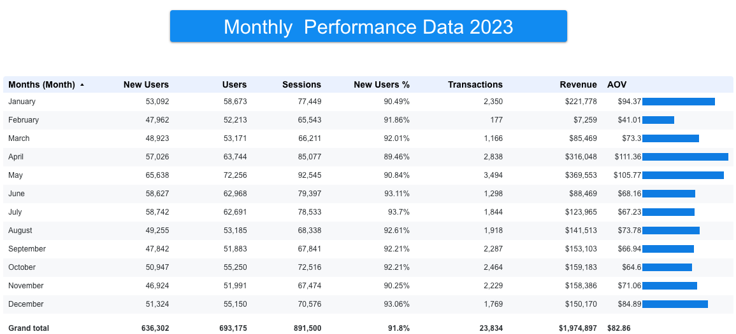
Figure 1: Monthly Performance data 2023 using channel performance data
Overall, the revenue generated by the business comes to $1,974,897 through 23,834 sales in 2023. The total number of users was 693,175 with 636,302 new users, giving a total new user percentage of 91.8%. The total AOV for the year stood out at $82.86. The best performance occurred in the period of April and May, when the firm earned its maximum revenues, sales, and AOVs.
The worst performance occurred in February when revenues and AOV were at their minimum. There was relative stability in revenues and sales but low AOV in the last six months.
- Which months should the team focus on their marketing efforts?
The team should focus on few key months to get the most out of their marketing efforts. February needs urgent attention, a possible RCA on the month to identify whether the dropped transactions and customer spending were because of seasonality/anomaly or something more concerning could be the cause. June and July are also worth a closer look, with transaction numbers fading after a strong run in April and May, inferring to a clear need for retention and promotional campaigns in those periods. October brought in good transaction volumes, but the AOV was low at $64.60, suggesting shoppers moved towards cheaper products thus opening the door for upselling and cross-selling opportunities.
6.2 Analysis on Campaign Performance Data
- Pie charts showing the percentage distribution of Campaign Performance across various metrices
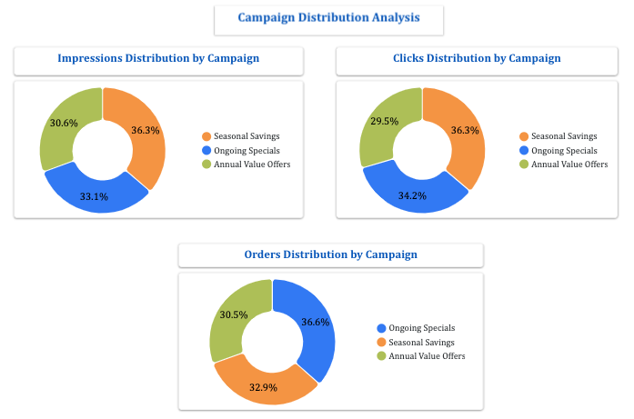Figure 2: Campaign distribution analysis on three instructed campaigns
As per figure 2, Seasonal Savings dominates Impressions & Clicks (36.3%) commanding the largest reach and engagement, on the other hand Ongoing Specials campaign leads the share of orders with 36.6%, despite lower impressions and clicks compared to Seasonal Savings.
- Topline indicators showing a comparison with the previous period
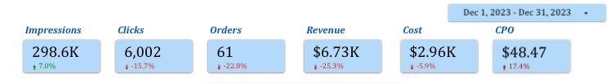
Figure 3: Topline indicators showcasing key metrics data on campaigns, comparing with October 2023 period
Th topline comparisons raises concerns as while the impressions or reach increased by 7% and somewhat the cost reduced vs October 2023 all the other key parameters like orders & revenue showed significant decline in the same periods indicating the poor performance of campaigns in December 2023
- Campaign Breakdown Section 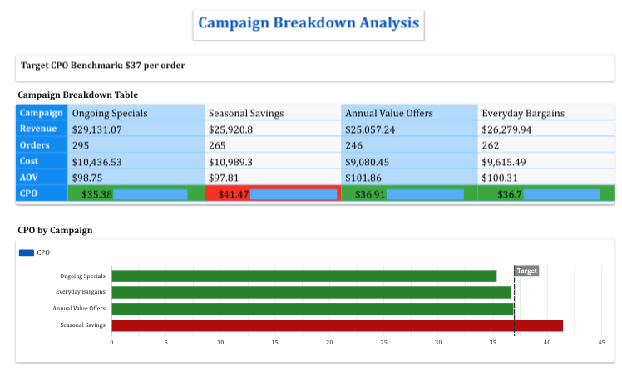
Figure 4: Campaign breakdown analysis showcasing key metrics for four campaigns and benchmarking CPOs with target line
Figure 4 showcases three out of four campaigns did not cross the CPO target line with only Seasonal Savings, being the only campaign to overshoot the target.
- Best & worst performing campaigns with recommendations
Ongoing Specials was the best-performing campaign, according to the Campaign Breakdown research. With a CPO of $35.38, which stayed below the goal benchmark of $37 per order, it produced the greatest revenue of $29,131.07. This suggests that the campaign was quite successful in turning consumer interaction into profitable sales while successfully managing acquisition expenses.
Seasonal Savings, on the other hand, earned the greatest CPO of $41.47, above the objective benchmark making it the campaign with the lowest performance. Even though the campaign produced respectable impressions and clicks its lower order share and higher acquisition costs point to a less profitable and efficient strategy.

7. Discussions, Limitations and Recommendations
The channel performance findings show that the company's 2023 customer acquisition efforts are being paid off which is drawing in a steady flow of new users, while Direct traffic is coming by most of the revenue, reflecting strong brand recognition. April and May months stood out to be with solid transactions, more customer spending, and revenue, making them a sensible focus point for planning future campaigns. February's dip looks like a seasonal slowdown but needs to analyzed in depth through RCA methods, targeted promotions or personalized ads could potentially curb the drop. Paid Search has brought in higher-value customers, while Display showed strong user base with only a couple of transactions; both have potential scope to grow if given more focus individually. Together, these patterns show us why customer analytics matters and is crucial as it is what makes identifying profitable channels, seasonality, and smarter marketing strategy possible.
On the campaign side, the analysis showed that Ongoing Specials was the best campaign because it made the most money and had a lower cost per order. Seasonal Savings was the weakest campaign because it had higher costs and less good results. The company should spend more money on Ongoing Specials and improve Seasonal Savings by making better ads and offers.
One problem with this analysis is that it only looked at numbers like revenue orders and CPO. It did not look deeply at customer feelings or loyalty. The analysis also did not fully show how social media and display ads helped customers before buying. In the future, the business should also look at customer lifetime, value retention rate, customer acquisition costs, and cart abandonment to make better marketing decisions and improve campaign performance.

8. References
Bleier, A., Harmeling, C. M., & Palmatier, R. W. (2019). Creating Effective Online Customer
Experiences. Journal of Marketing, 83(2), 98–119. https://doi.org/10.1177/0022242918809930
Chaffey, D., & Ellis-Chadwick, F. (2022). Digital marketing: Strategy, implementation and practice (8th ed.). Pearson.
de Haan, E., Wiesel, T., & Pauwels, K. (2016). The effectiveness of different forms of online
advertising for purchase conversion in a multiple-channel attribution framework. International
Journal of Research in Marketing, 33(3), 491507.https://doi.org/10.1016/j.ijresmar.2015.12.001

Järvinen, J., & Karjaluoto, H. (2015). The Use of Web Analytics for Digital Marketing
Performance Measurement. Industrial Marketing Management, 50(1), 117–127.
https://doi.org/10.1016/j.indmarman.2015.04.009

Kannan, Pallassana and Li, H. Alice, Digital Marketing: A Framework, Review and Research
Agenda (March 1, 2017). P.K. Kannan and Hongshuang (Alice) Li (2017) "Digital marketing: A
framework, review and research agenda", International Journal of Research in Marketing, 34(1),
pp. 22-45., Available at SSRN: https://ssrn.com/abstract=3000712
Kumar, V., & Reinartz, W. (2018). Customer relationship management: Concept, strategy, and tools (3rd ed.). Springer.
Pauwels, K., & van Ewijk, B. (2020). Enduring Attitudes and Contextual Interest: When and
Why Attitude Surveys Still Matter in the Online Consumer Decision Journey. Journal of
Interactive Marketing, 52(7), 20–34. https://doi.org/10.1016/j.intmar.2020.03.004

9. Appendices
Analysis on Channel Performance Data - Microsoft Looker Link: https://datastudio.google.com/u/0/reporting/e370864f-6de2-4c40-8e63-e2293ec71a09/page/m3AyF
Analysis on Campaign Performance Data – Microsoft Looker Link:
https://datastudio.google.com/u/0/reporting/aba56f24-abca-473e-b98c-228a341f36b7/page/ksRyF

